
Relationships and Regulation Policy
1. Vision and Approach
At Ffederasiwn Ysgol Penrhyn-coch ac Ysgol Penllwyn, we believe every child thrives in an environment of trust, respect, and safety. Our approach prioritises relationships and emotional regulation, ensuring every pupil feels valued, connected, and ready to learn.
2. Core Principles
- Behaviour = Communication: Behaviour signals needs. We respond with curiosity and care.
- Regulate before educate: We support co-regulation first, learning second.
- Relationships first: Invest time in building trusting, supportive connections.
- Repair over punish: We focus on accountability, learning, and restoring relationships with a focus on natural and logical consequences.
- Compassion: Treat every child with the same care we would show our loved ones.
- Inclusion—every child belongs.
- Understanding Behaviour: Recognise that behaviour communicates needs; stay curious and observant.
- Calm, Thoughtful Responses: Respond thoughtfully and proportionately rather than react impulsively. Least intrusive, last resort.
- Safety: Prioritise physical and emotional safety at all times.
- Proactive Support: Anticipate needs, stay vigilant, and prevent difficulties where possible, working in partnership with families and external agencies.
- De-escalation: Focus on reducing tension, supporting calmness.
- Regulate, Then Educate: Help children regulate before expecting learning or reflection.
- Respect: Treat every child and colleague with dignity and fairness.
- Reflection: we learn from what happened and improve.
- Consistency: Provide reliable routines and predictable responses with flexibility through reasonable adjustments.
- Teamwork: Support one another and work collaboratively as a staff team, and with families.
3. Expectations
4.1 Pupil Expectations (Our Rules)
We keep it simple and memorable:
- Ready – prepared to learn, follow routines, try our best.
- Respectful – kind words and actions; care for ourselves, others, and our environment.
- Safe – make choices that keep everyone safe.
These are taught, modelled, practised, and prompted in all areas of school life.
The 4 purposes of Curriculum for Wales form the basis to the following characteristics we hope to foster in the children and adults within Ffederasiwn Ysgol Penrhyn-coch and Ysgol Penllwyn
- Perseverance – Keep trying, even when something is tricky.
- Enthusiasm – Be excited and eager to learn and join in.
- Concentration – Focus on what you are doing and try your best.
- Kindness – Use kind hands, kind feet, and kind words.
- Teamwork – Work together and help each other.
- Flexible – Try to cope when plans change and be ready to try new ways.
- Listening – Listen carefully when others are speaking.
- Resilient – Bounce back when things go wrong and don’t give up.
- Polite – Use good manners like “please” and “thank you”.
4.2 Staff Expectations
All staff:
- Build warm, trusting relationships with children/young people and families.
- Consistent calm adult Behaviour
- First attention for best conduct
- Relentless routines
- Scripting difficult interventions
- Restorative follow up
- Record concerns accurately and communicate with colleagues and parents/carers.
- Reflect

5. Roles and Responsibilities
- Headteacher
  - Implements the policy and ensures a safe culture.
  - Reports to governors on impact and safeguarding.
  - Ensures staff training and resourcing.
- Class Teachers
  - Teach and reinforce expectations and routines.
  - Plan for regulation and inclusion; make reasonable adjustments.
  - Use relational responses and restoration; communicate with families.
- Support Staff
  - Provide consistent cues, co-regulation, and targeted support.
  - Contribute to observations, plans, and reviews.
- Parents/Carers
  - Support the home-school agreement and shared language (Ready, Respectful, Safe).
  - Engage in dialogue; work in partnership to support regulation.
- Governing Body
  - Monitors policy effectiveness and statutory compliance.
  - Advises on disciplinary matters at a strategic level.

6.1 Universal Provision (for all pupils)
- Environment: clear routines, visual supports, regulation-friendly spaces.
- Language: calm, specific, future-focused (“Next time…”, “Let’s try…”).
- Relational routines: warm welcomes, check-ins, predictable transitions.
- Teaching behaviour: explicit instruction, modelling, rehearsal, restorative and reflective conversations.
- Recognition: specific praise for effort, kindness, and repair.
6.2 Targeted Support (for some pupils)
- Check-in/check-out, adult key worker, structured breaks.
- Zones of Regulation (or equivalent) taught and reinforced.
- Reasonable adjustments: seating, task adaptation, movement breaks, flexible entry/exit, sensory tools.
- Individual regulation plans where patterns emerge.
6.3 Specialist/Individualised Support (for a few pupils)
- Multi-agency planning with parents/carers.
- Risk reduction plans where necessary.
- Interventions: emotion coaching, social skills, restorative conferencing.
- Review cycle: assess–plan–do–review.
7. Consequences that Teach
Our responses prioritise learning, accountability, and repair. We use a spectrum of responses—starting with the least intrusive, always proportionate.
7.1 Natural Consequences
Where safe and appropriate, we allow real-life, cause-and-effect outcomes that foster learning without shame.
- Example: If equipment is misused and breaks, the natural next step is helping to fix/replace or assisting in that area to understand its value.
Why we use them: They encourage reflection, ownership, and help prevent recurrence in a dignified way.
7.2 Logical Consequences
When natural consequences aren’t possible or safe, staff use logical consequences that are directly linked to the behaviour.
- Examples:
  - Off-task and disrupting others → short, supported break to regulate; return with a clear re-entry prompt.
  - Unkind words → restorative conversation, and making amends (e.g., apology letter, helping the peer/group).
  - Unsafe corridor behaviour → rehearsal of safe routine with an adult and modelling.
Principles: short, instructive, and paired with repair. Never shaming or punitive.
7.3 Restorative Practice (Repair)
- What happened? What were you feeling at the time? Who has been affected and how?
- What do we need now to feel okay/safe?
- What can we do to make things right?
- What will help us do better next time?
- What should happen next? How will you repair your relationship with …?

8. Reasonable Adjustments
We make reasonable adjustments for pupils with additional needs to ensure fairness and inclusion. Adjustments may include: differentiated instructions, visual timetables, alternative regulation spaces, sensory tools, chunked tasks, additional processing time, key adult support, flexible consequences, or adapted transitions. Adjustments are documented on individual plans where relevant.

9. Use of Physical Intervention (Last Resort)
Physical intervention may be used only when:
- It is reasonable, necessary, and proportionate, and
- There is an immediate risk to the safety of the pupil or others, or to prevent serious damage.
Safeguards:
- De-escalation attempted first where possible.
- Minimum force for the shortest time.
- Staff trained in approved methods.
- Immediate recording, notification to parents/carers, and post-incident review focused on learning and risk reduction.

10. Exclusion
Exclusion (internal or fixed term) will be considered only when:
- There is a serious or persistent risk to safety/learning, and
- Other strategies are insufficient or exhausted, and
- It is lawful, reasonable, and proportionate.
All statutory processes, notifications, and supports are followed. Reintegration is planned with a clear, supportive re-entry.

11. Recognition and Positive Culture
We build motivation through belonging, purpose, and progress, not just rewards. Examples include:
- Specific, sincere recognition of effort and kindness, and character traits. (wrist bands for those who have gone over and above: 3 awarded at the end of each day, 2 chosen by a member of staff, 1 chosen by other pupils. Individual class rewards system e.g. dojos, cards with hole punches, recognition board The adults will pick a Behaviour which they wish to encourage and practice (for instance kind hands, good listening) and when children are spotted demonstrating this behaviour their photo will go on the board to be celebrated! The aim is that all of the children should get onto the board in any given day or session and that it is a team effort! If all of the children get onto the board the class will celebrate, but the reward will be essentially intrinsic. The aim is for the children to want to behave well because it feels good and is the correct thing to do – not for any extrinsic reward. )
- Celebration of learning (work displays, star of the week, phone calls home on a weekly basis).
- Class community rituals (rewards assembly, group rewards, gratitude circles, collecting points for a team for a specific behaviour and get rewarded as a group for a specific behaviour that is being reported).
- Opportunities to contribute (roles of responsibility, school council meetings).
- Triangulated praise and recognition - raised to someone else while the child can hear it, helping to reinforce confidence and positive behaviour.

12. Communication, Recording, and Reporting
- Class-level logs of patterns and responses (A-B-C: Antecedent-Behaviour-Consequence).
- Teacher’s Centre/Teams for safeguarding.
- Parents/carers informed in a timely, solution-focused manner of significant concerns.
- Data termly to governors: trends, exclusions, physical interventions, pupil/parent voice, and impact of actions.

13. Training and Support
- Induction for all staff on relational practice, de-escalation, restorative approaches, and legal duties.
- Ongoing CPD on regulation, SEND/ALN, trauma-informed practice, and inclusive classrooms.
- Supervision/reflective practice opportunities for staff wellbeing.

14. Monitoring and Review
- SLT monitors consistency, hotspots, and pupil experience.
- Pupil/parent voice informs improvements.
- Policy reviewed regularly or earlier if needed.

15. Appendices See attached Powerpoint

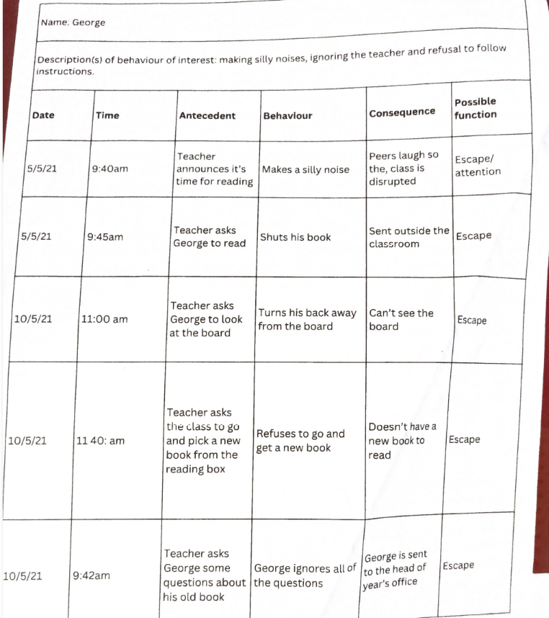

Templates Archives - TeamTeach Knowledge Hub

